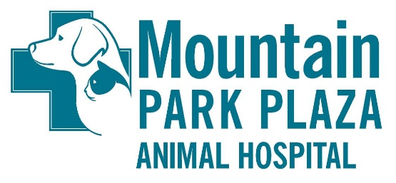

BOARDING RELEASE FORM
Pet(s) Name(s): Last Name:
Check-In Date: Check-Out Date:
Contact Name / Phone Number:___________________________________________________
Secondary or Emergency Name / Phone Number:_________________________________

Would you like your pet(s) to have (check one):
BATH___________ GROOM________
MINI GROOM__________ NONE OF THE ABOVE_______

Feeding instructions daily (check one): 1x ( ) 2x ( ) Free Feed ( ) Qty: ____________
Food (check one): ( ) I supplied food ( ) Please feed kennel food

Medication information:
___________________________________________ __________________________________________
___________________________________________ __________________________________________
*please specify upon drop-off when medications were last administered*

Personal items brought (toys, blankets, cages):_____________________________________

***ALL PETS MUST BE CURRENT ON THEIR VACCINATIONS TO STAY AT OUR FACILITY. IF YOU USE
A VETERINARY HOSPITAL OTHER THAN OURS, VACCINATION HISTORY NEEDS TO BE SUPPLIED TO US AT DROP OFF. ALL ANIMALS WILL BE GIVEN A CAPSTAR WHILE BOARDING. ***

DOGS are required to have updated:
Rabies, DHPP, KCV (Bordetella), Fecal Exam, and Heartworm Exam
CATS are required to have updated:
Rabies, FVRCP, and Fecal Exam.

[IN CASE OF AN EMERGENCY ILLNESS OR INJURY, l, THE UNDERSIGNED, DO HEREBY GIVE MY CONSENT
FOR THE DOCTORS OF MOUNTAIN PARK PLAZA ANIMAL HOSPITAL TO TREAT, PRESCRIBE FOR, OR OPERATE UPON MY PET(S) WHILE HE/SHE/THEY ARE BOARDING AT THIS FACILITY. WE WILL MAKE EVERY
EFFORT TO CONTACT YOU FIRST FOR AUTHORIZATION, BUT WILL PROCEED FOR THE HEALTH AND SAFETY OF YOUR PET(S) IF NEEDED.]

Signature: Date:

If I am unable to pick up my pet(s),is authorized to do so.
In this case, please leave a form of payment with our front office staff.

